AGENT WORKFLOW
My module provides the agent-facing workflow for an incident: an agent can view an incident, change its status, assign an agent, and add/update a comment.
Architecture I implemented
Your part follows the ASP.NET Core MVC architecture:
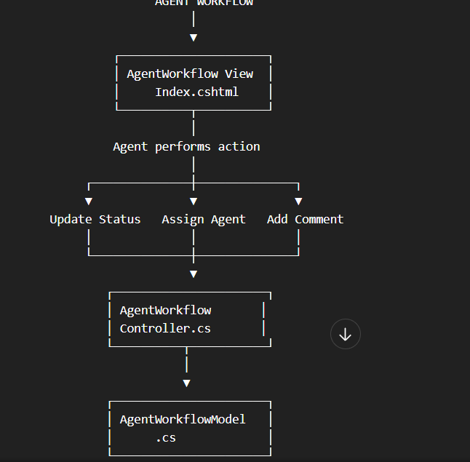
This is consistent with ASP.NET Core MVC: the controller handles requests/actions, the model represents the data/state, and the Razor view presents the UI.

1. AgentWorkflowModel.cs — data structure
created:
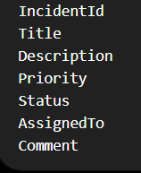
So the workflow has all the basic information an agent needs.
For example:
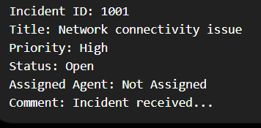
2. AgentWorkflowController.cs — your main logic
implemented four important operations.
A. View incident
Index()
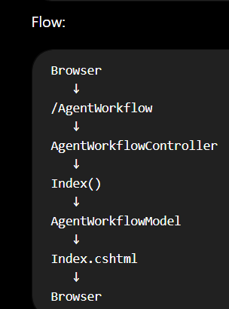
B. Update incident status
implemented:
UpdateStatus()
The agent can select:
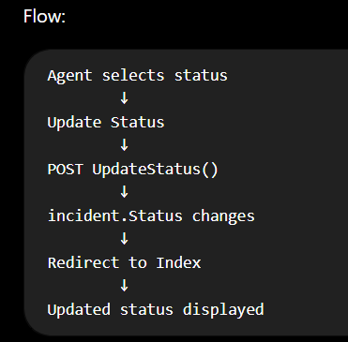
C. Assign an agent
implemented:
AssignAgent()
The agent enters an Agent ID.
Example:
Agent ID: 205
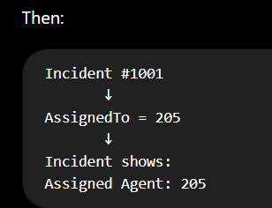
You also handled removing an assignment if the value is empty.

D. Add a comment
implemented:
AddComment()
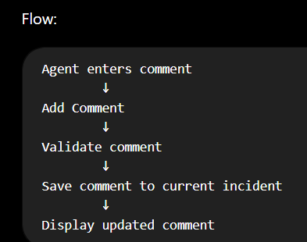
3. Index.cshtml — agent UI
page now contains four sections:
Incident Details
Displays:
- Incident ID
- Title
- Description
- Priority
- Status
- Assigned Agent
- Comment
Update Incident Status
Dropdown:
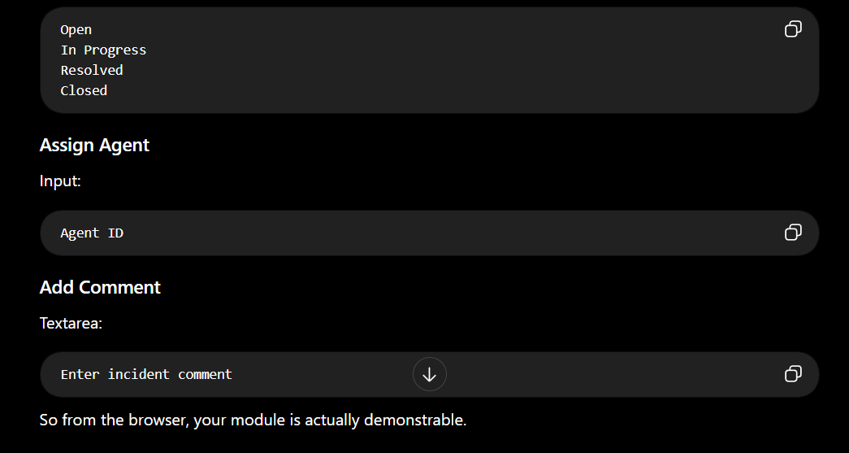
4. Security/ASP.NET features added
POST actions contain:
[ValidateAntiForgeryToken]
That is good practice for MVC form submissions.
Your forms use:
POST
rather than putting update operations directly into GET requests.

5. What current architecture DOES NOT contain
This is important.
current module does not yet directly connect to the database.
It currently uses:

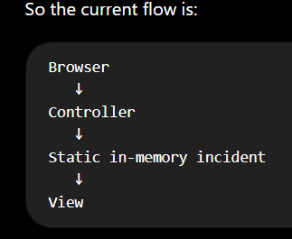
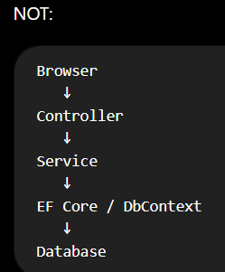

6. Why we have NOT added the database
Because your team project has separate modules and the database/infrastructure is being developed elsewhere.
Repo already has
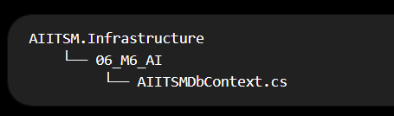
but that context currently concerns the AI module, not a completed Incident/Agent Workflow persistence layer.
So you should NOT randomly modify that database context just to make your module look integrated.
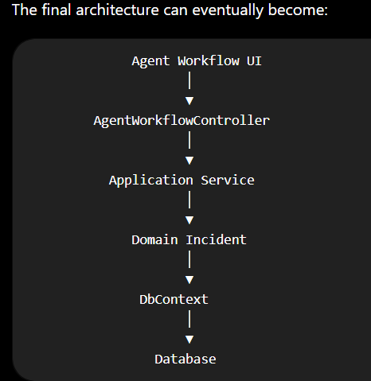
But that is integration work, not something you need to invent independently right now.

7. Where AI fits later
AI should NOT be shoved into your AgentWorkflowController just because your overall project is called AI-ITSM.
The eventual flow can be something like:
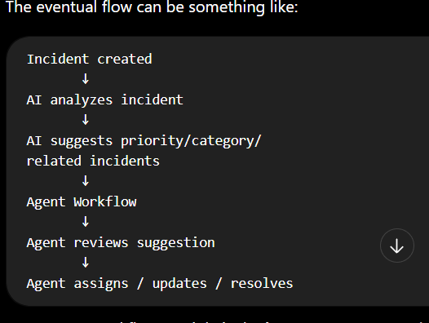
Agent Workflow module is the human/agent operational layer.
The AI module is a separate concern.
ASP.NET MVC itself also recommends keeping controllers focused on request handling and delegating business concerns to appropriate services rather than making controllers do everything.

8. final integrated architecture
Eventually, when everyone finishes, your part should connect approximately like this:
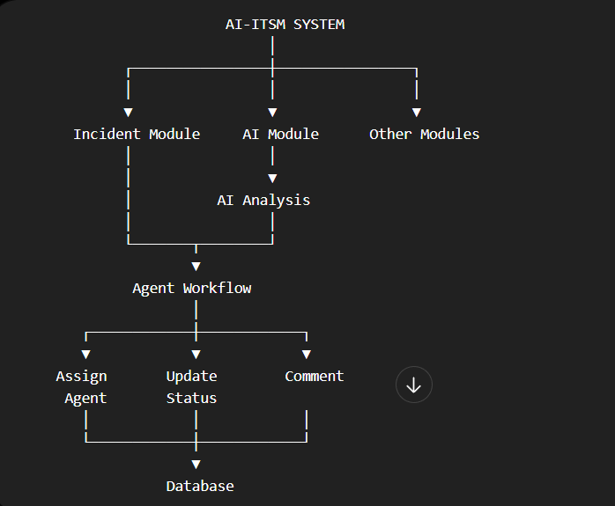
That's the future integration architecture, not something you need to implement alone right now.

Person 3 – Agent Workflow update:
My standalone Agent Workflow module is completed. I implemented the MVC model, AgentWorkflowController, and Index.cshtml UI. The module currently supports viewing incident details, updating incident status, assigning/removing an agent, and adding comments. POST actions include anti-forgery validation. The module is currently using an in-memory/static incident model so it is independent of the unfinished database/AI modules. Database and AI integration will be done later during final project integration once the relevant modules are ready. My changes have already been committed and pushed to main.

My standalone Agent Workflow functionality = done.
Database integration = later with the team.
AI integration = later with the team.
Final connection to the Incident Management/database/AI pieces = integration stage.

UI DESIGN (This is how it will show after updating status assign agenyt and adding comment)
